Table of Contents

Part A – Project Planning 2

Part B – Database Design 6

Part C – Implementation and Testing 9

References 38

# Part A – Project Planning

Overview –

I Damanpreet working as a database designer at the Albert Football Club . This club provides training to the players by assigning physio and coaches to the players . Club provides them ground to practice , proper diet and training kits to the players , only the members of the club have the access. Club have staff to take care of the players like manager , IT Admin , coaches and physio . Medical staff is also there for the players.

Requirements –

As a database designer there is a requirement for a computerized system to manage information about the club like staff , players , coaches etc. The various functions that a database should have are

* User can update the data
* Insert the data
* Delete the data

Database should be scalable that can be used to big clubs and accommodate any number of employees .

Other Requirements:

Players data should contain names, addresses, phone numbers. Physio ID is the identifier of Physio along with their specialization (orthopedic, chiropractic, and acupuncture) , name and office addresses and phone numbers should be saved. The club employees data like employee ID, an employee type (Manager, and IT Admin) and employee id as an identifier along with their names, email addresses, phone number and office addresses needs to be stored. A Player can be linked with many physios . Employees can be linked to one physio.

Expected Outcomes –

* + ER diagram
  + Export Files
  + Avoid redundancy
  + Database which is used to save the data
  + Increase the efficiency in maintaining data
  + Data Privacy
  + Data Backup

Technical details –

* + *DBMS Software*: *MySQL*

*MySQL is an opensource relational database which is used to create applications on a large scale and small scale also. MYSQL AB is the initial company that have developed this database. It follows all the rules of the relational database i.e. EF Code Rules. Database used to store data which can easily be accessed and maintained easily. It is a RDBMS (Relational Database Management System) which have tables, rows, columns, indexes, primary key, foreign key, compound key, referential integrity. It has various API’s for creating and maintaining database and tables*

* + *Tools : MySQL Workbench*

MySQL Workbench is a graphical tool for working with MySQL databases. MySQL Workbench fully supports MySQL server versions 5.6 and higher. Compatible with older MySQL server 5.x versions, except It does not support MySQL server versions 4.x.

* + *Backup:*

*Database backup is the strategy to create a copy of the database and even the transaction log is also saved in the backup along with the database.*

*Methods of Backup*

* + 1. Full Backup

Full copy of the database is kept and the transaction records also . It is a time-consuming process.

* + 1. Transaction Log

All the transaction logs are saved and once the new transaction logs comes up, the previous transaction logs are deleted. The size of the backup file is less.

* + 1. Differential Backup

This type of backup stores only the differential backup.

* + 1. Incremental Backup

In the incremental back-up the data there is a concept of safety id.

Backup Schedule:

**Monday:** Full backup

**Tuesday To Saturday**: Differential backup

**Sunday**: Incremental backup

* + *Recovery*

There are two methods that are primarily used for database recovery. These are:

* + 1. **Log based recovery** -  In this technique , in case of failures all the transaction logs are stored in the secure area and from there database can be recovered.
    2. **Shadow paging -** This technique is beneficial in the case of failure happens in between the transactions.

# Part B – Database Design

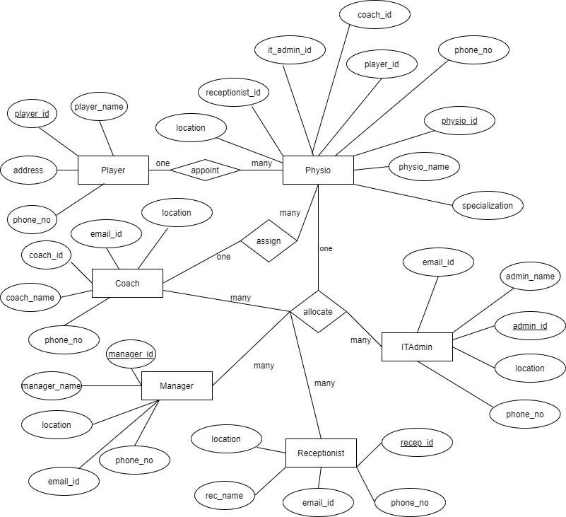EER Diagram –

Schemas –

First NF

Physio Player Employee

Physio_id Player_id employee_id

Physio_name Player_name employee_type

Location address employee_name

Phone_no phone_no email_id

Physio_specialization phone_no

Location

Second NF

Physio Player Receptionist Manager IT Admin Coach

Physio_id Player_id receptionist_id manager_id admin_id coach_id

Physio_name Player_name receptionist_name manager_name admin_name coach_name

Location address email_id email_id email_id email_id

Phone_no phone_no phone_no phone_no phone_no phone_no

Physio_spec location location location location

Third NF

Physio Player Receptionist Manager IT Admin Coach

Physio_id Player_id receptionist_id manager_id admin_id coach_id

Physio_name Player_name receptionist_name manager_name admin_name coach_name

Location address email_id email_id email_id email_id

Phone_no phone_no phone_no phone_no phone_no phone_no

Physio_spec location location location location

Player_id

Receptionist_id

Coach_id

Manager_id

Admin_id

# Part C – Implementation and Testing

Creating Database

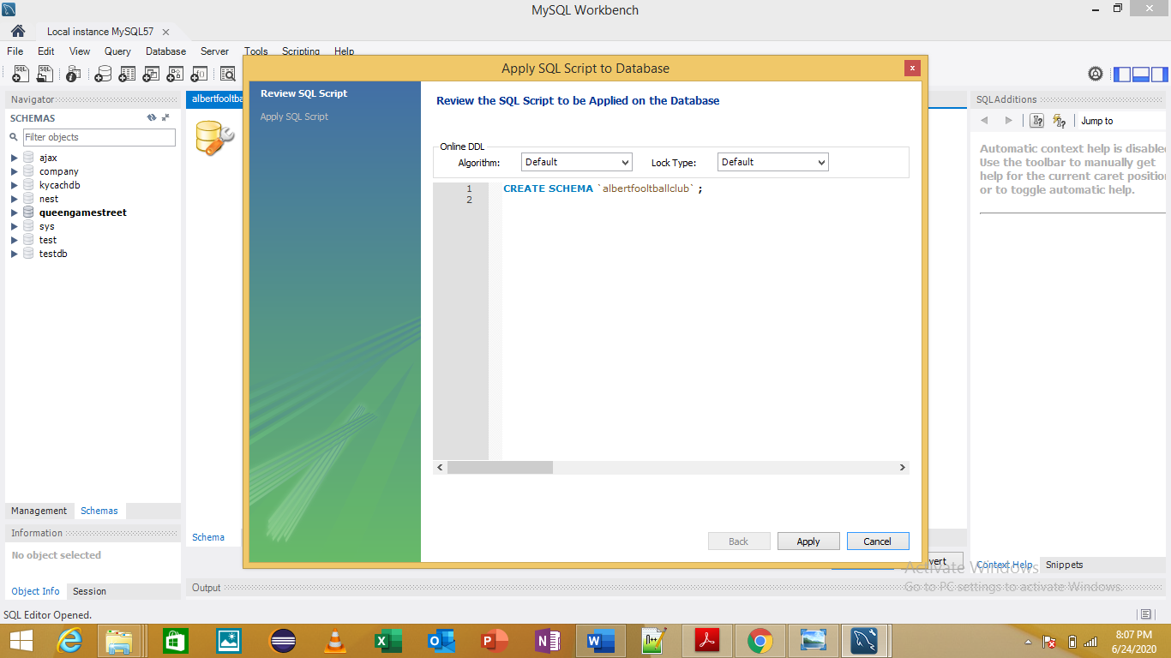

Player Table

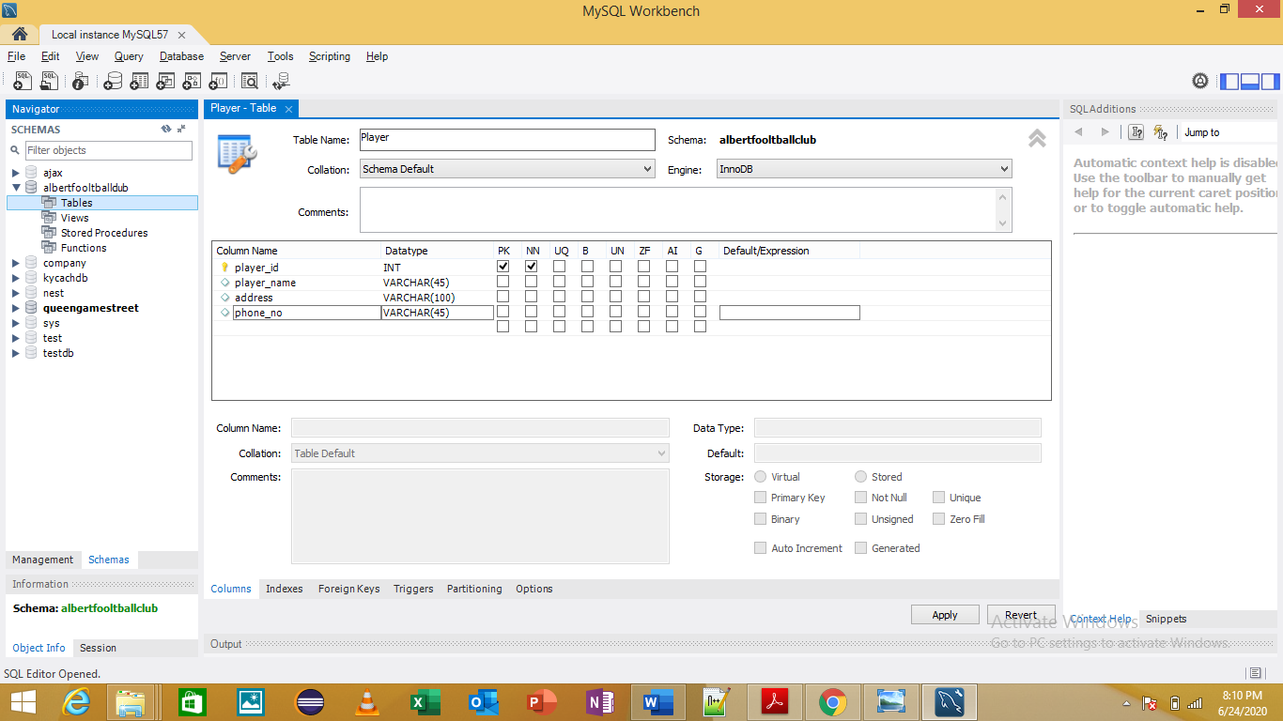

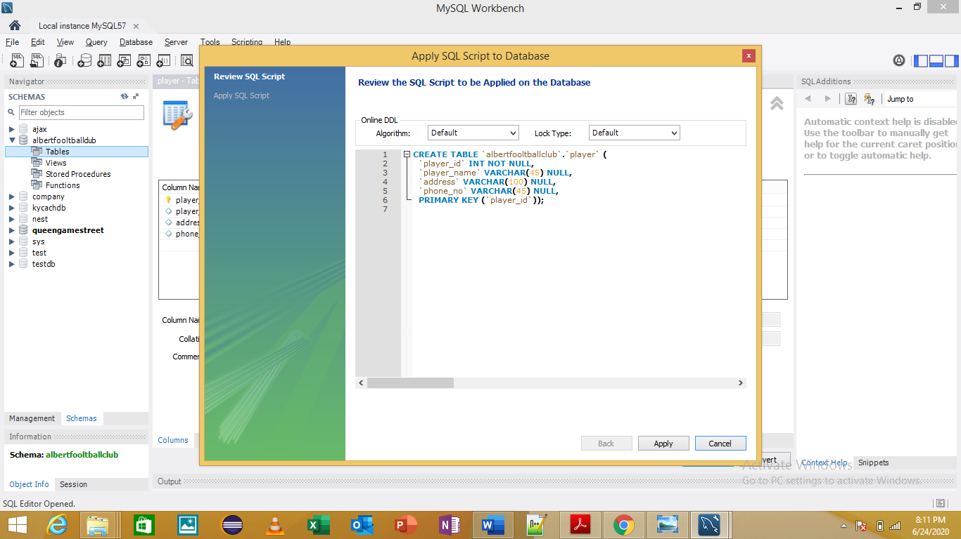

Receptionist Table

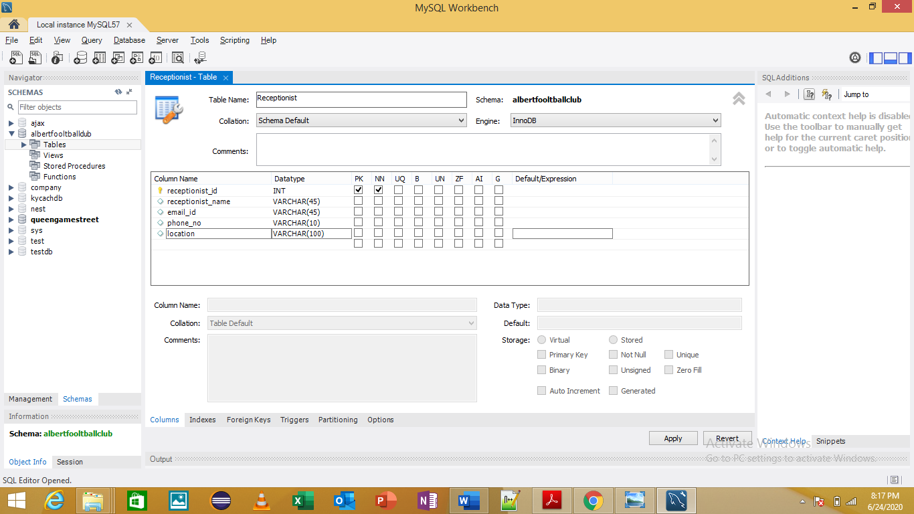

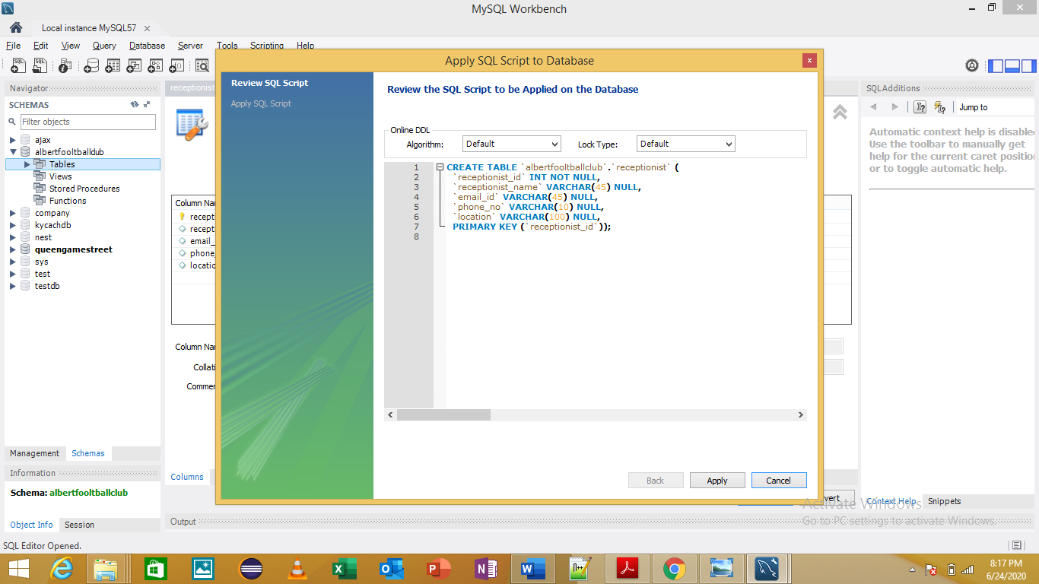

Manager Table

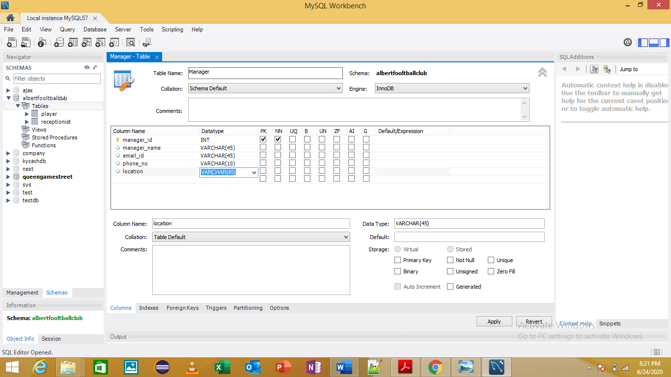

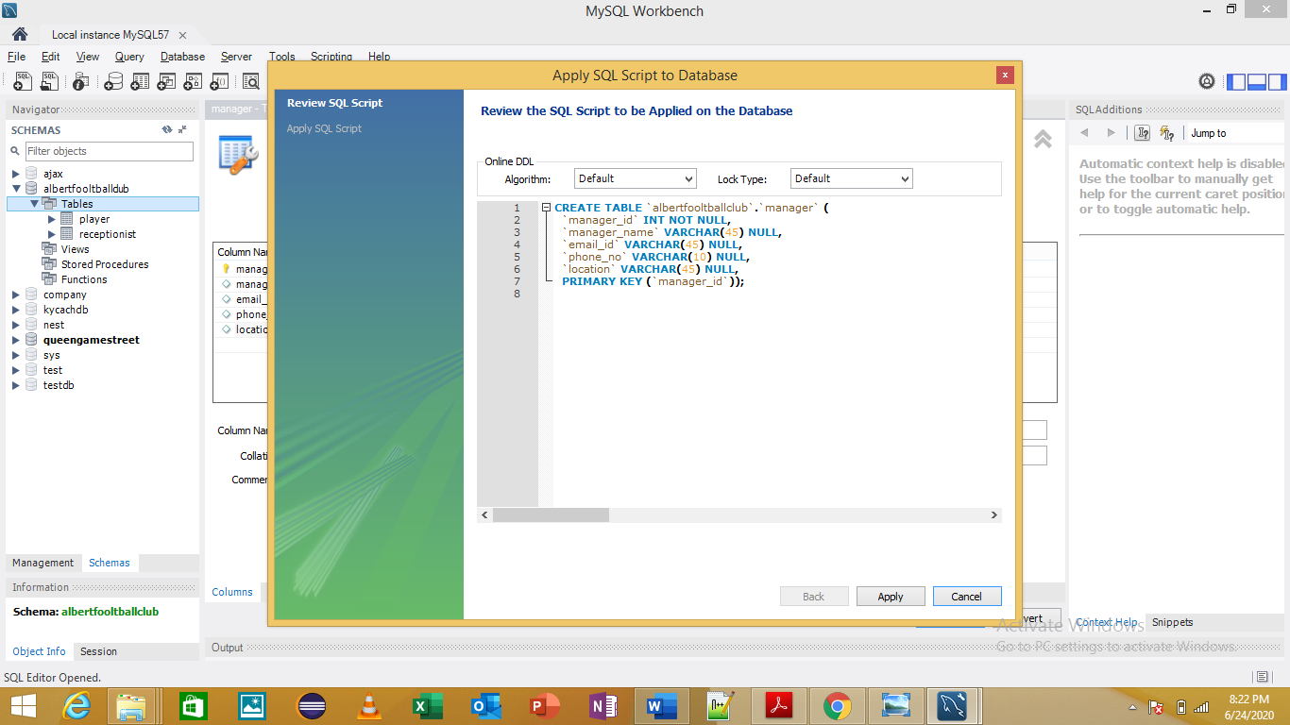

ITAdmin Table

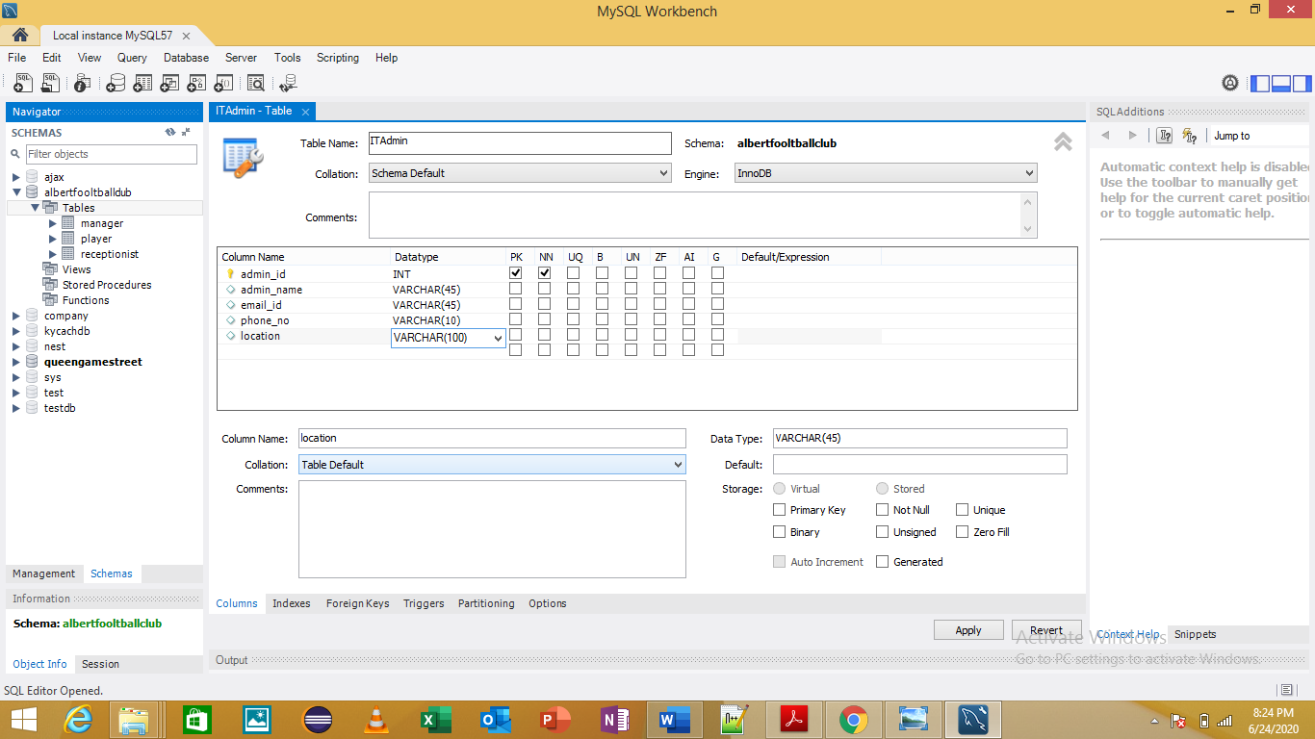

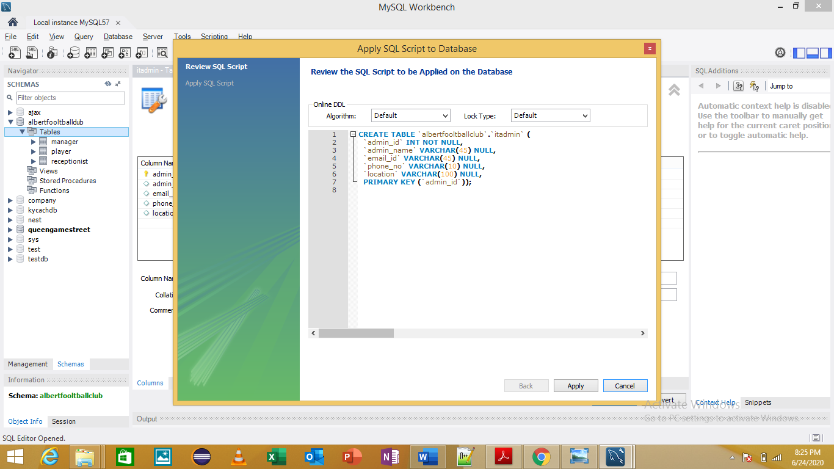

Coach Table

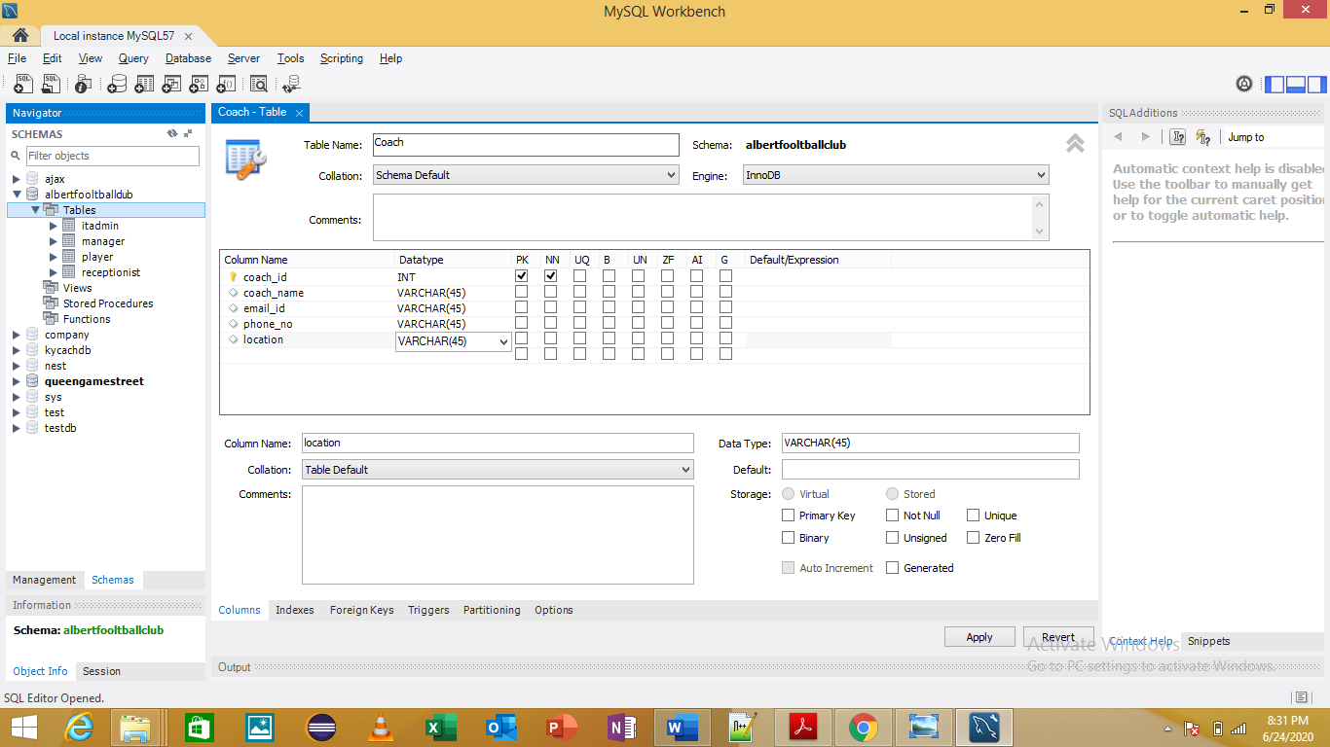

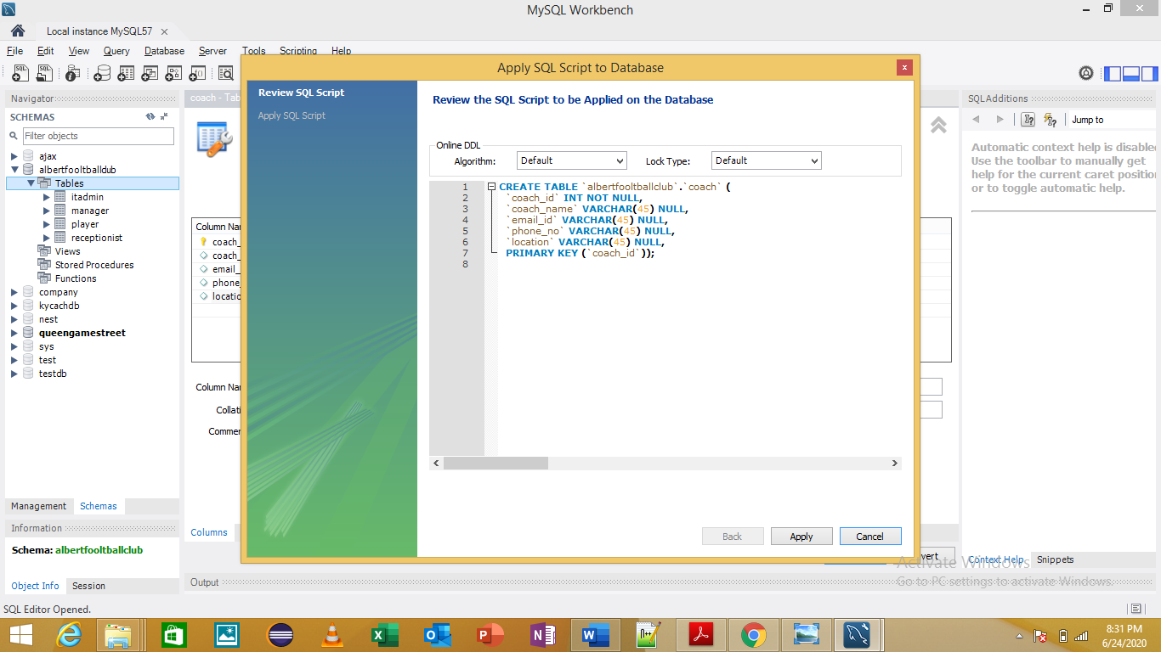

Physio Table

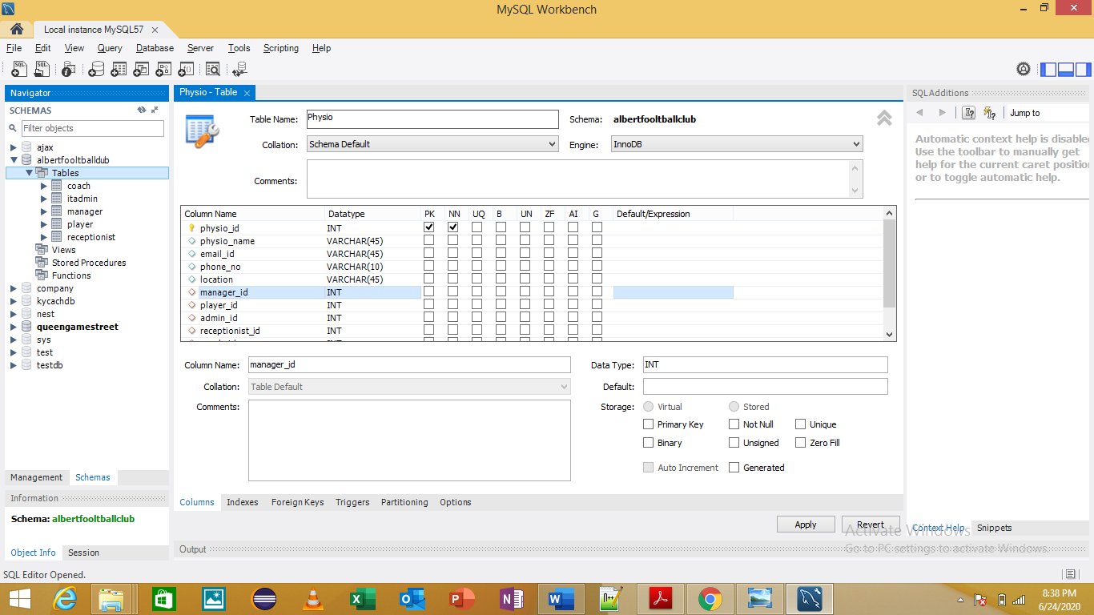

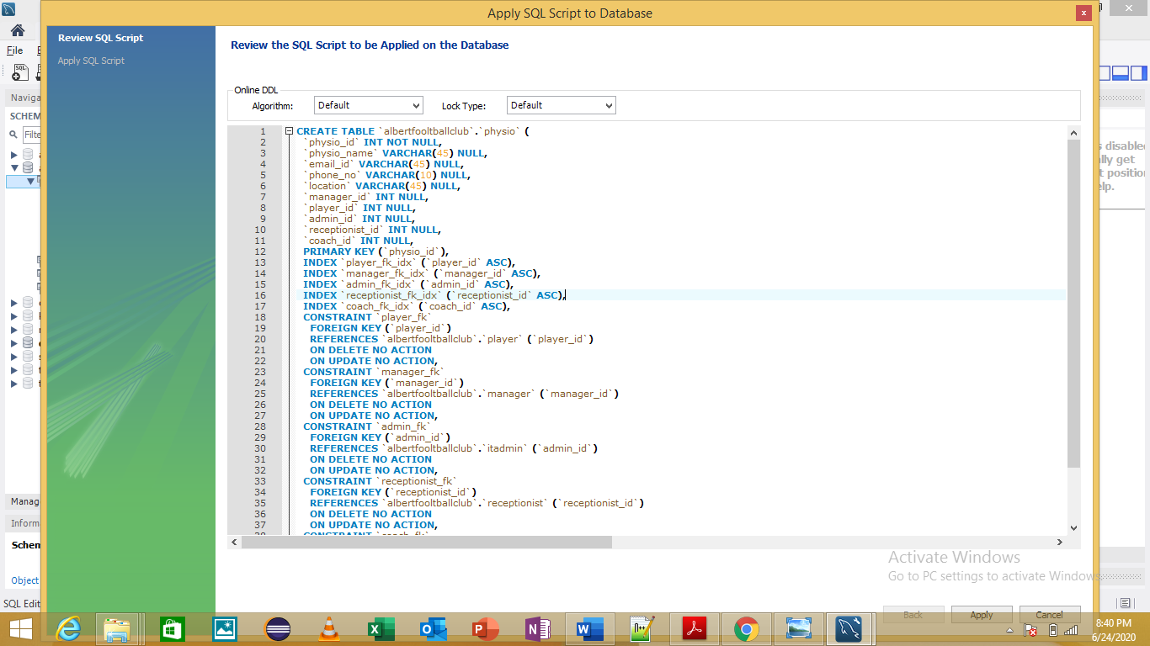

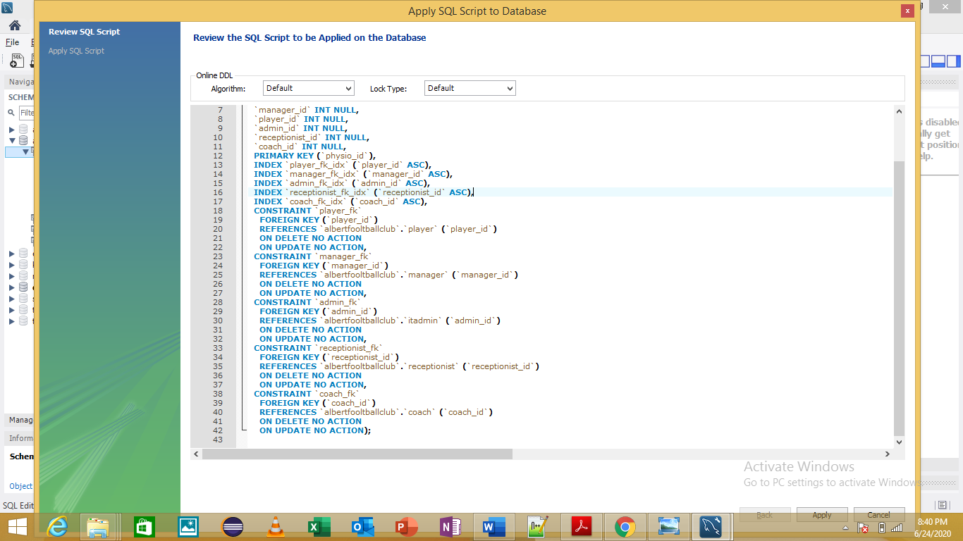

Foreign Keys

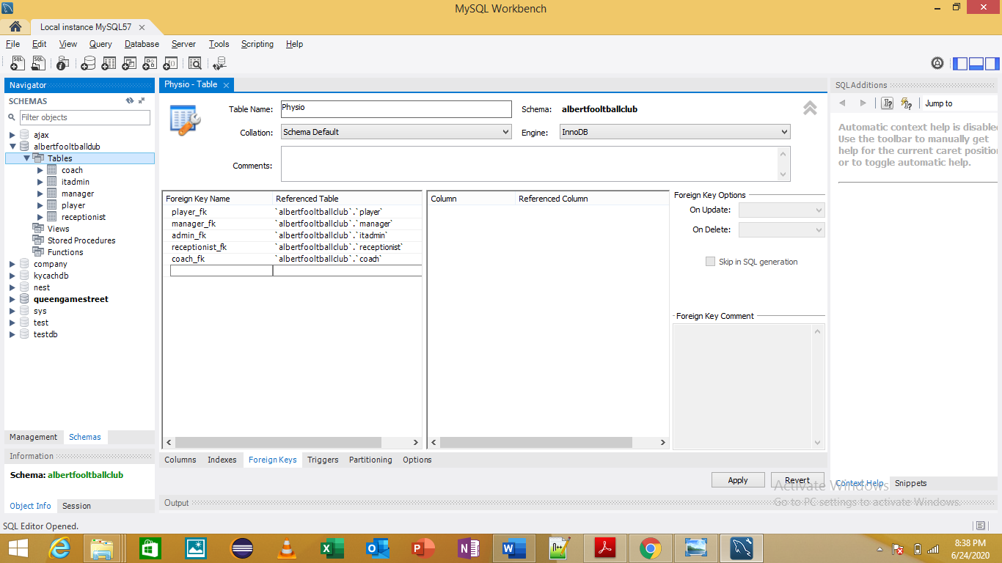

RELATIONSHIP BETWEEN THE TABLES

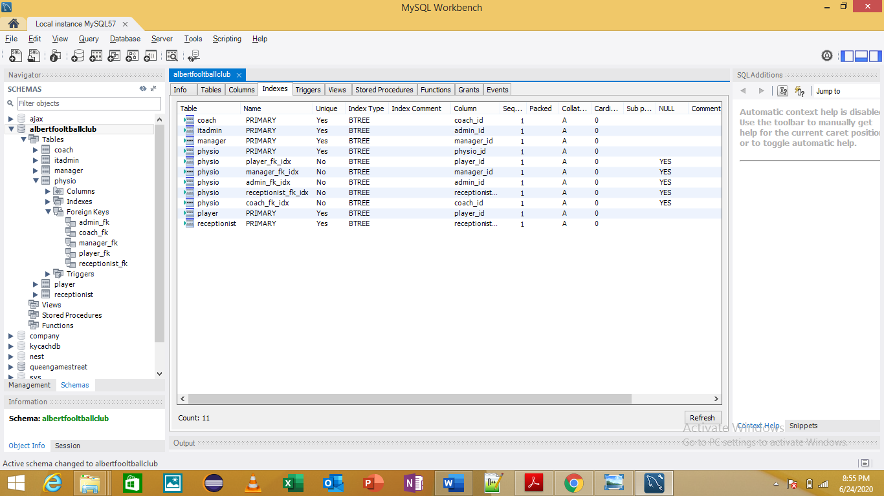

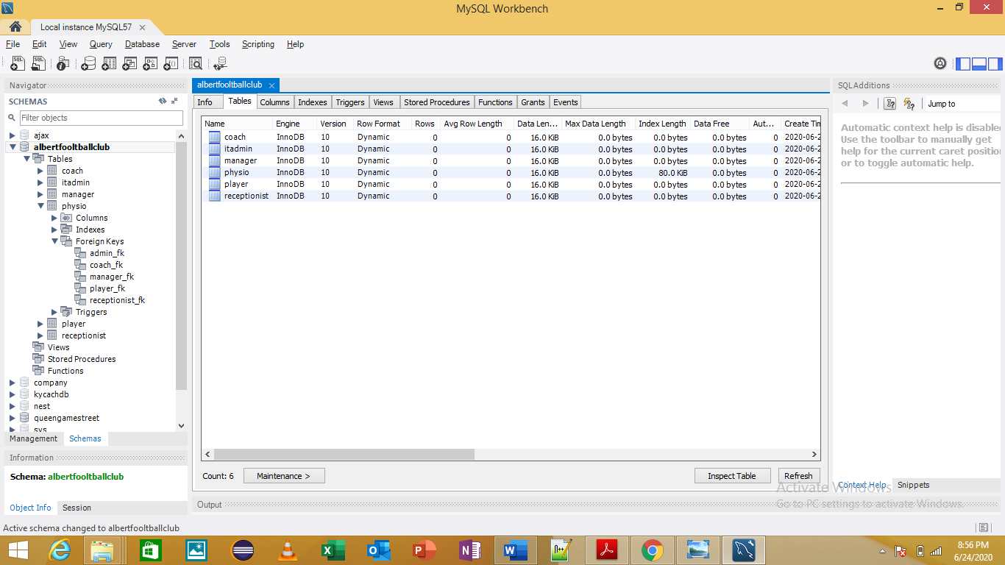

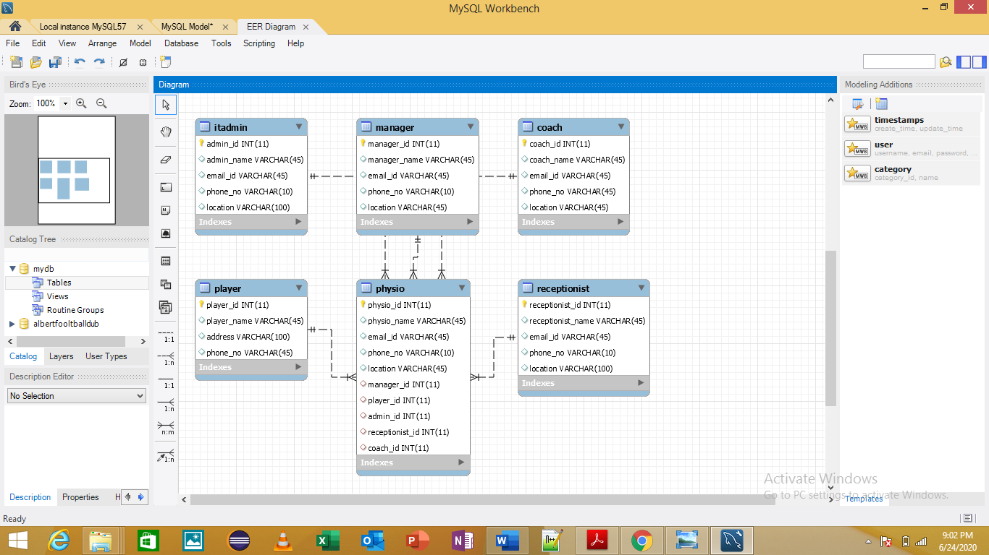

1. 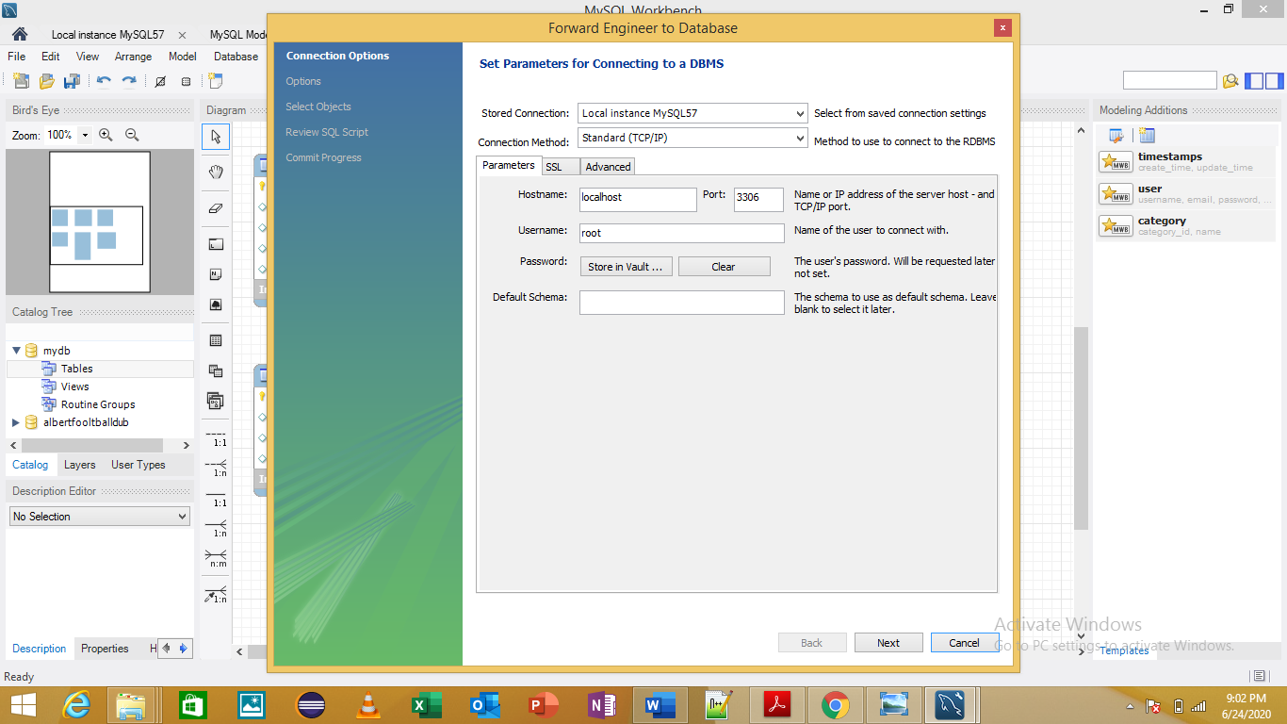Database Testing

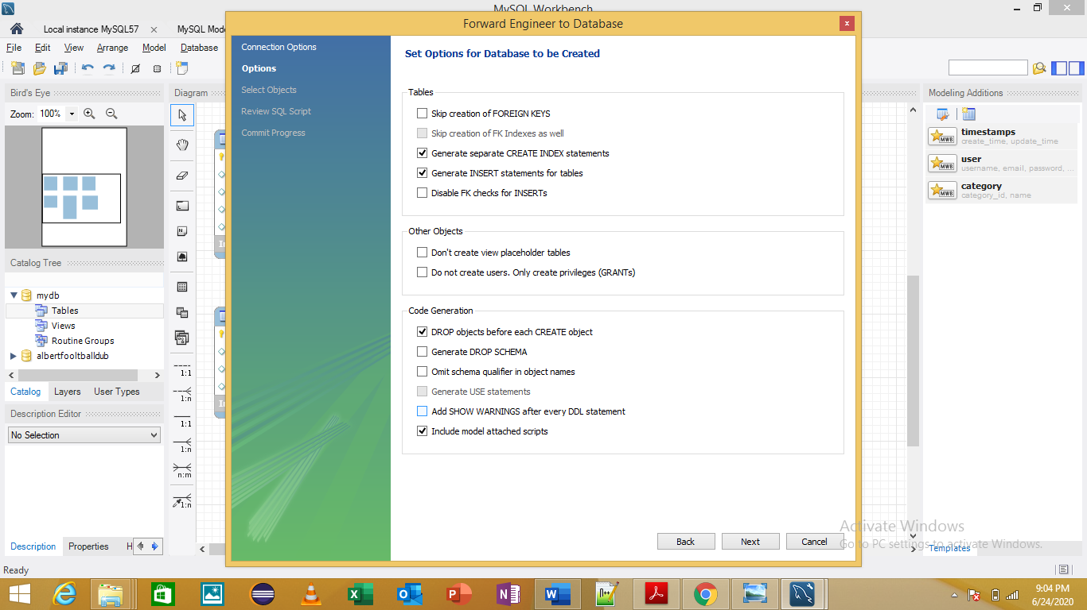

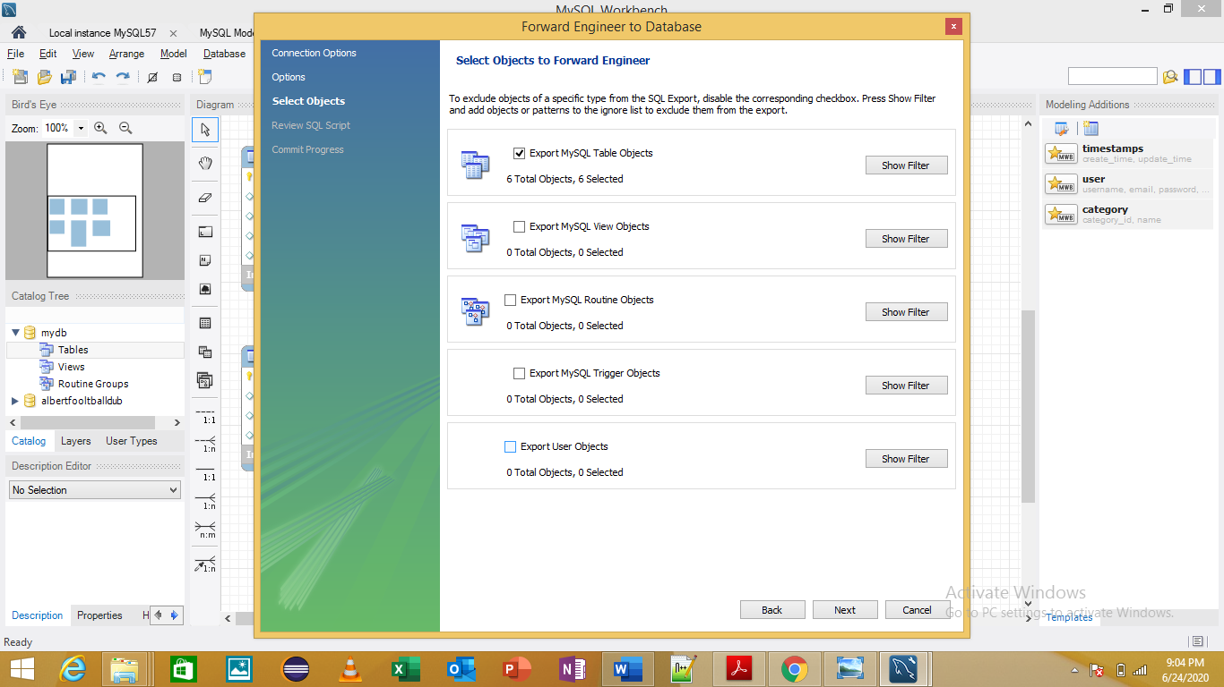

Coach Table

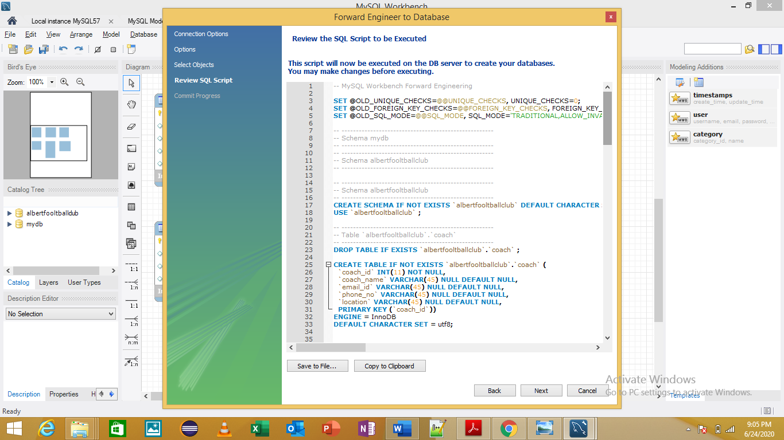

IT Admin and Manager Table

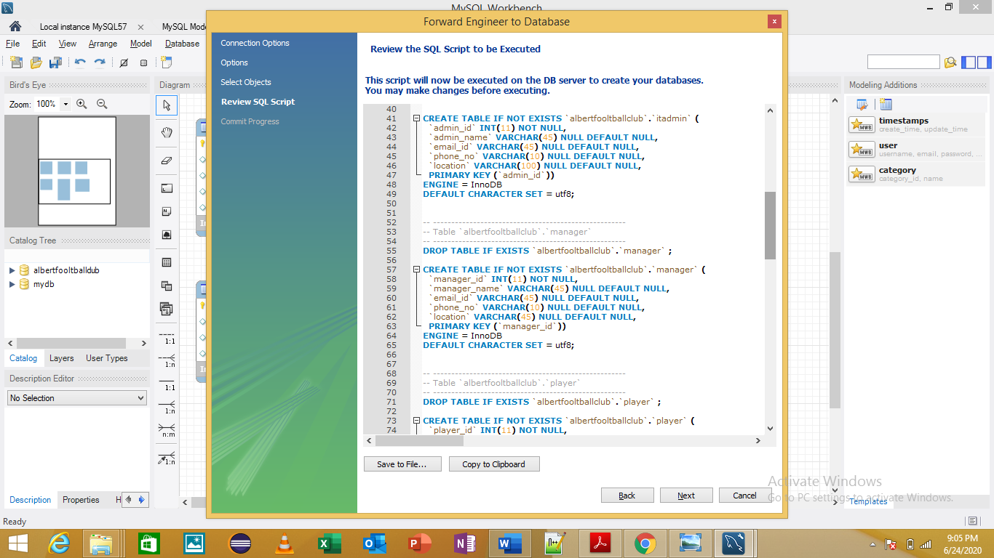

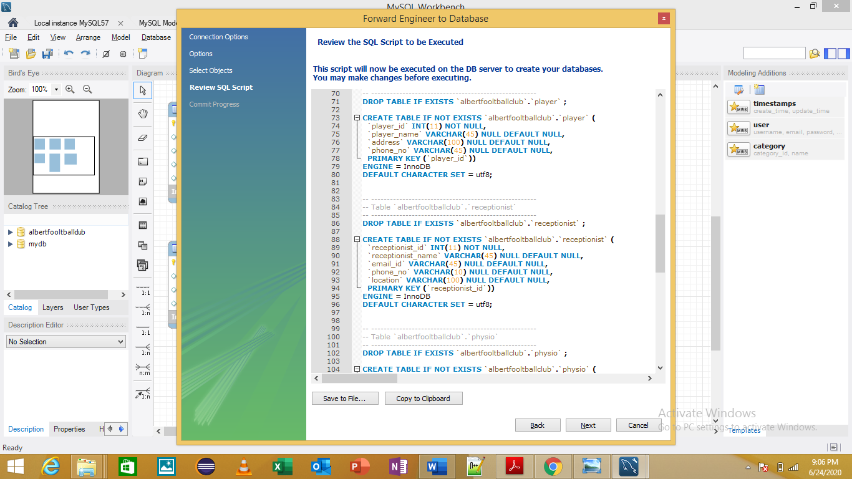Player and Receptionist Table

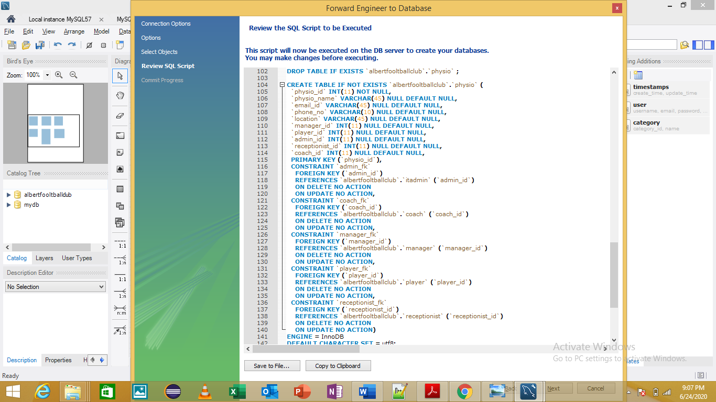Physio Table

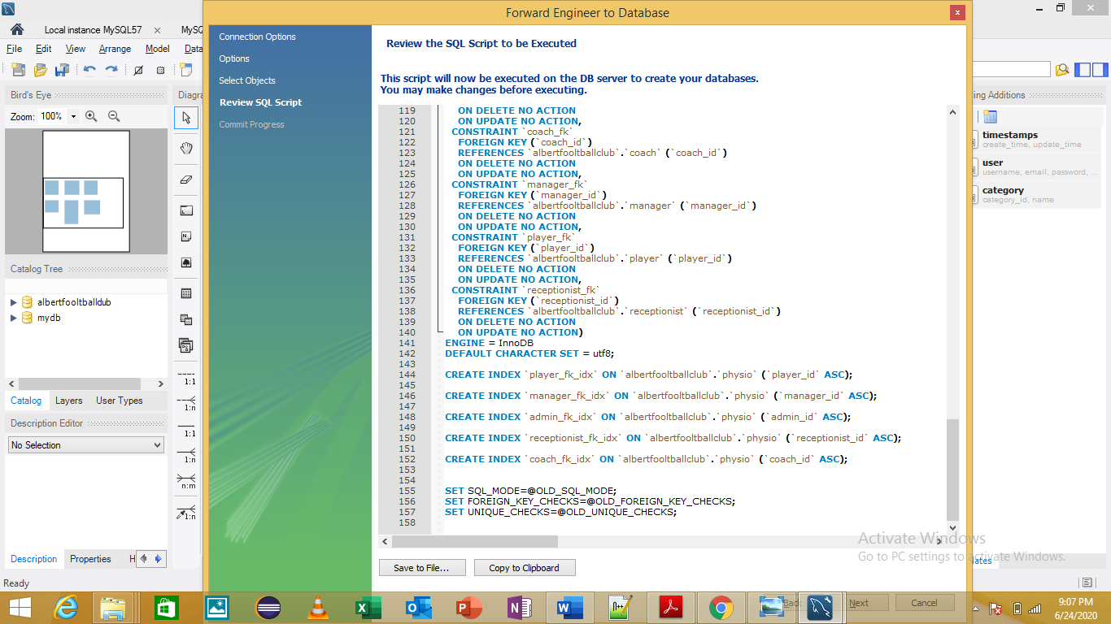Indexes

POPULATING THE DATABASE

PLAYER

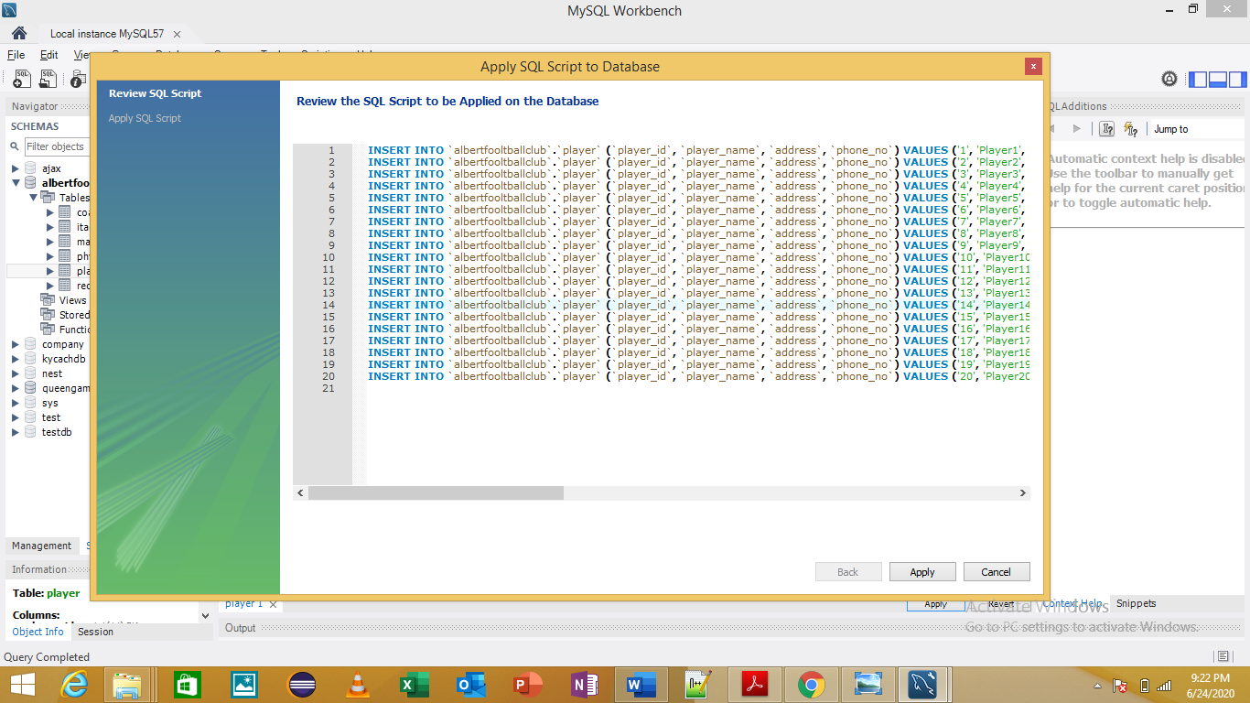

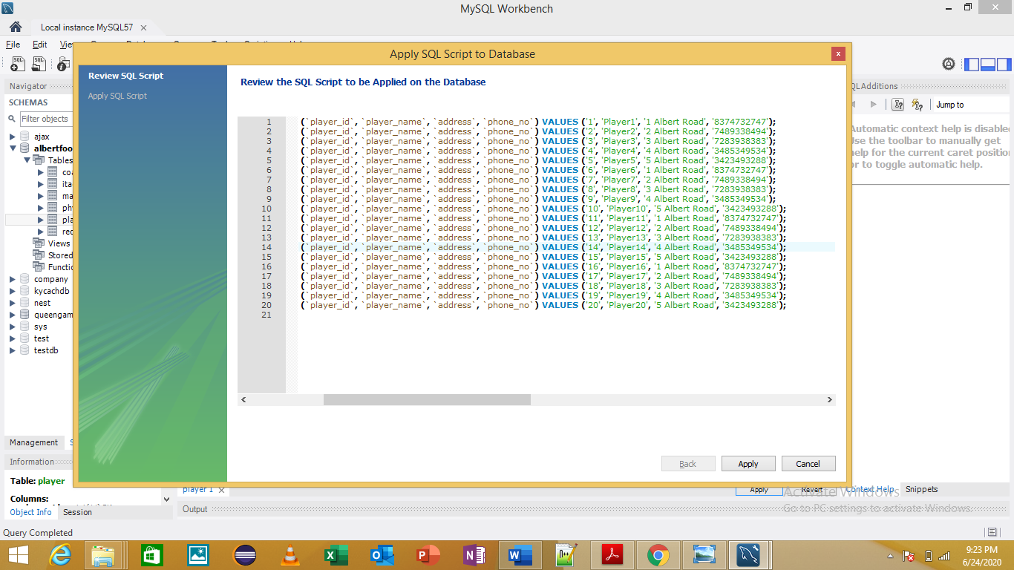

Manager Table

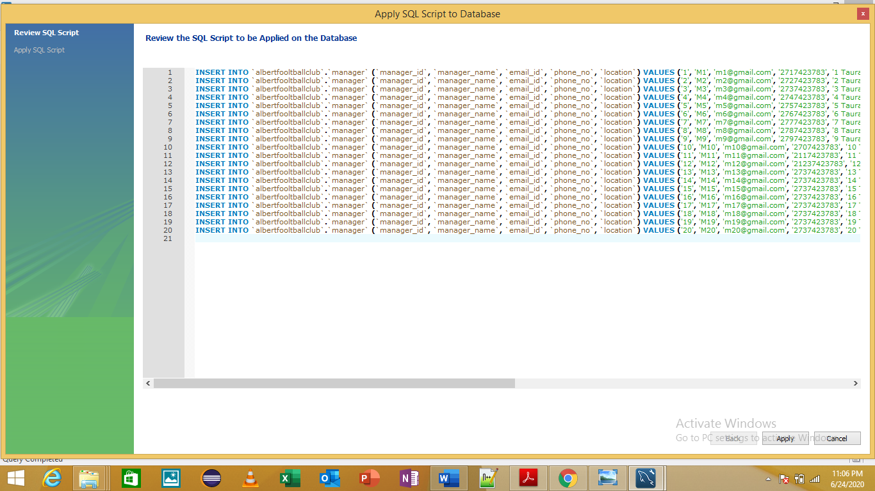

Coach Table

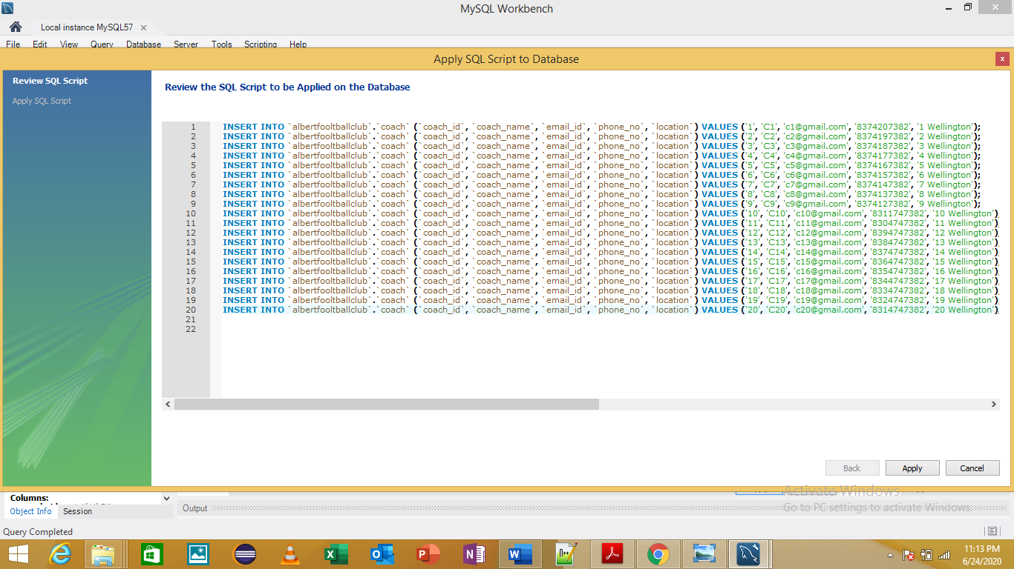

Receptionist Table

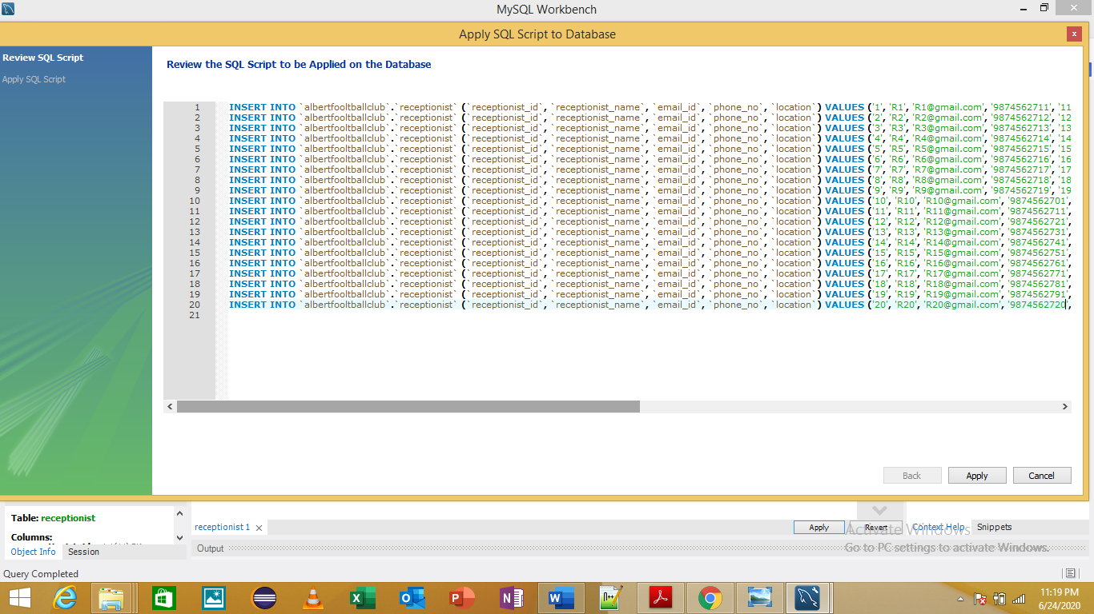

ITAdmin Table

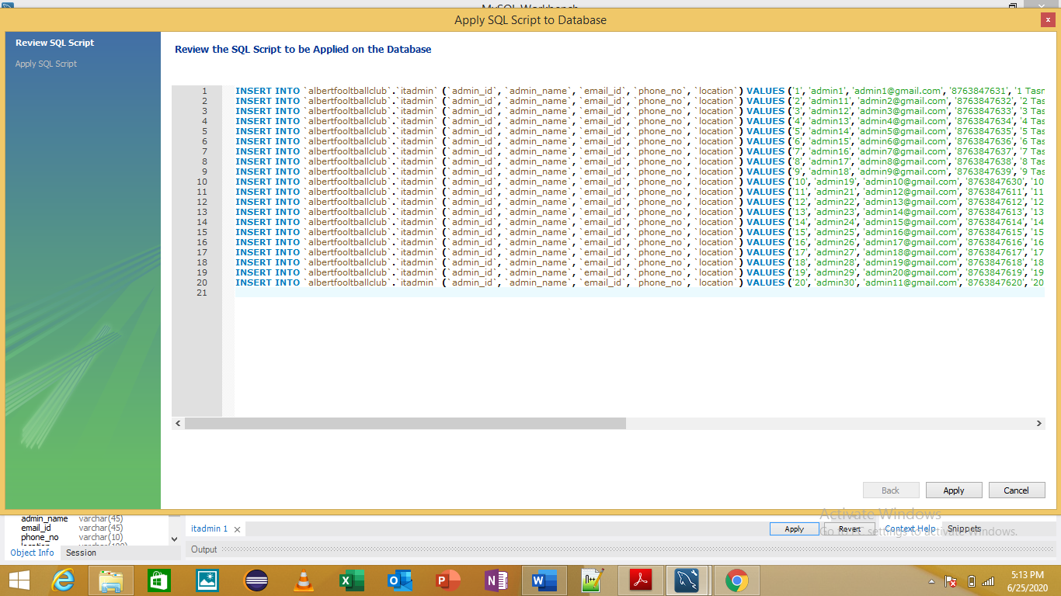

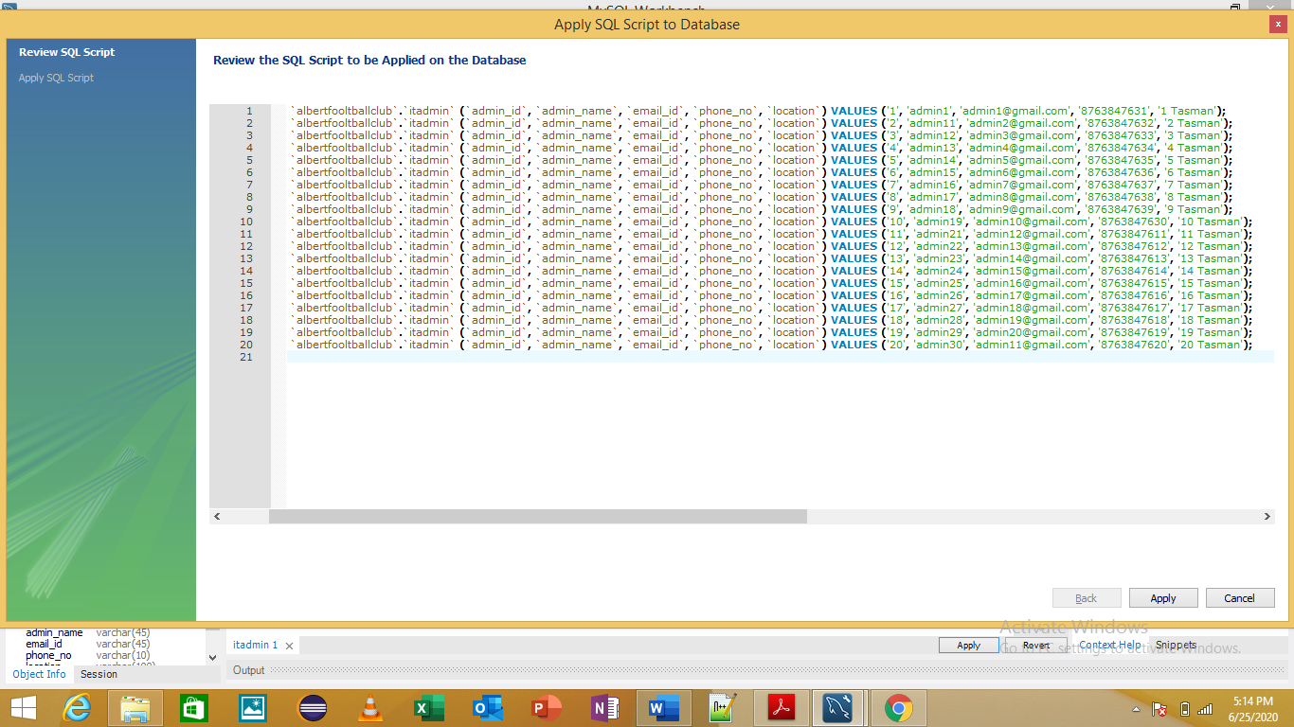

Physio Table

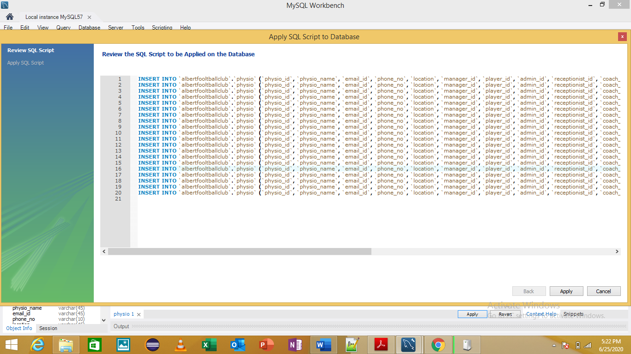

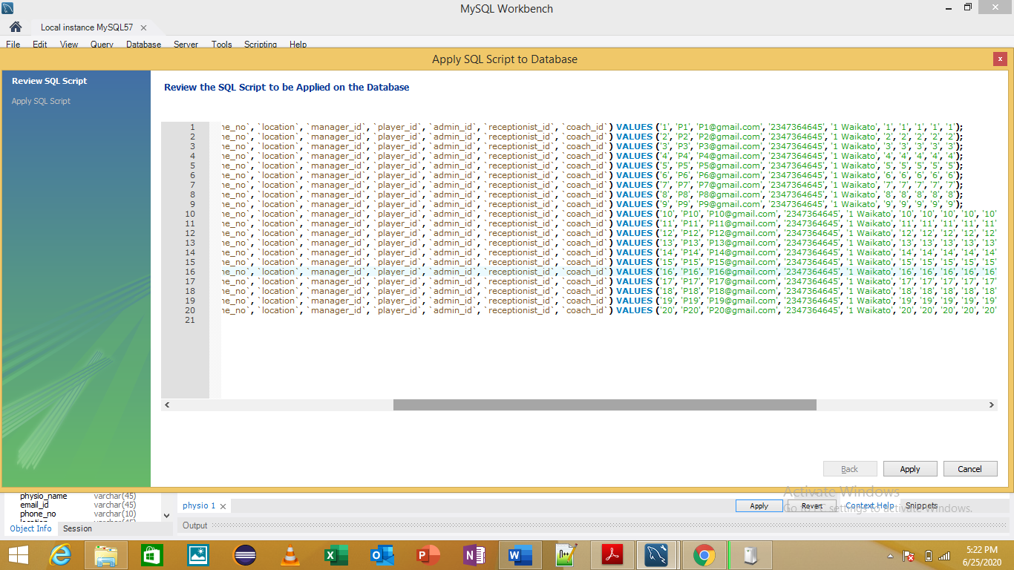

Inserting Data

Before

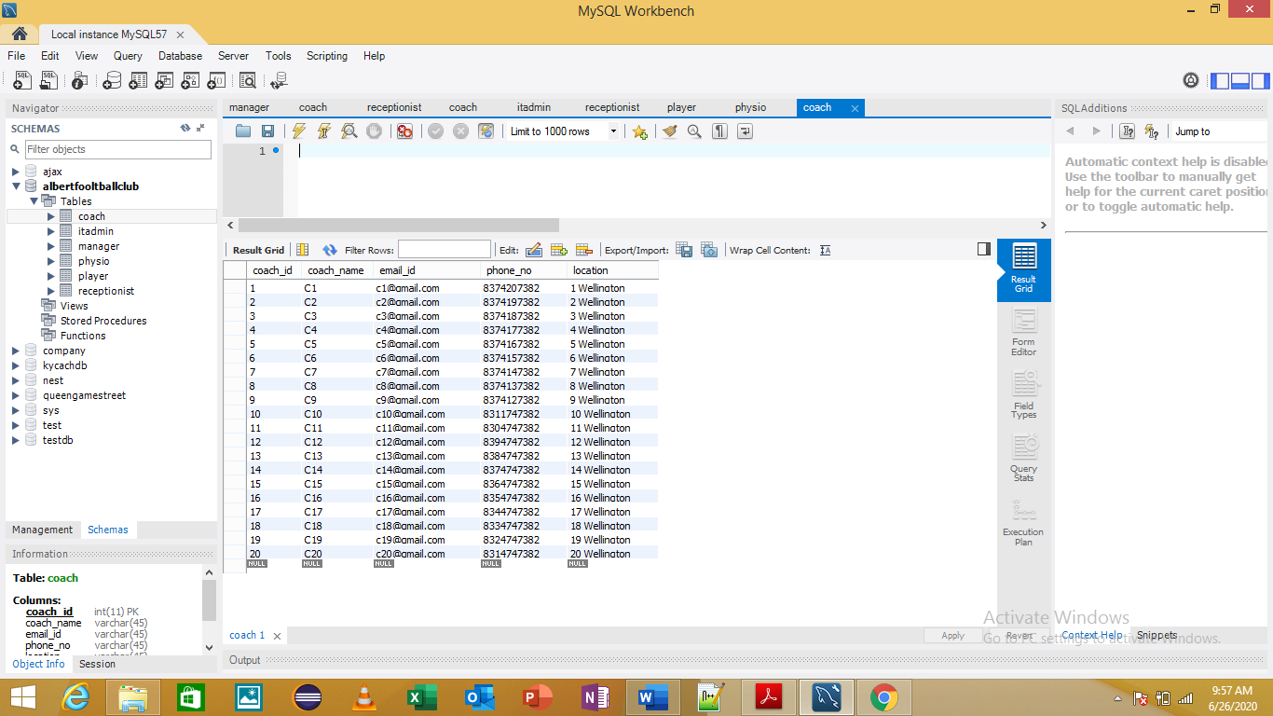

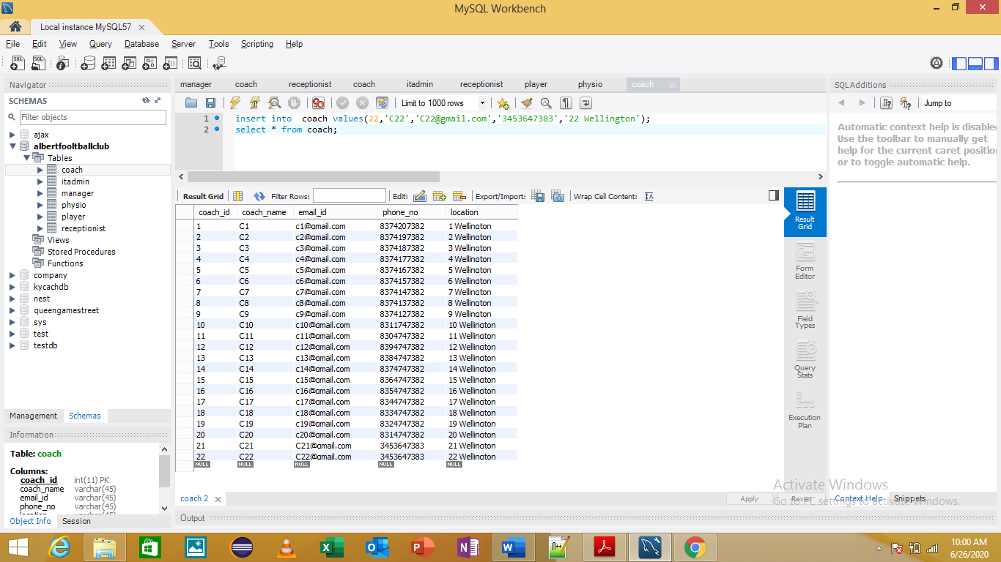

Deleting the data

Before

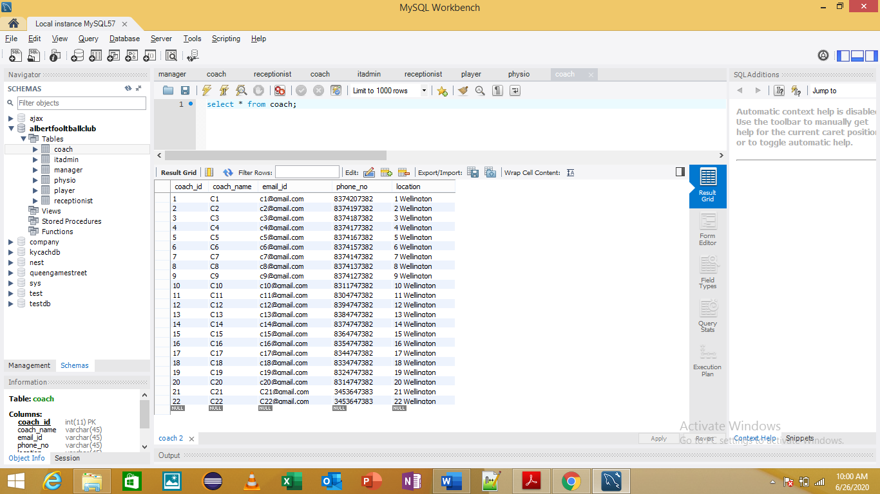

After

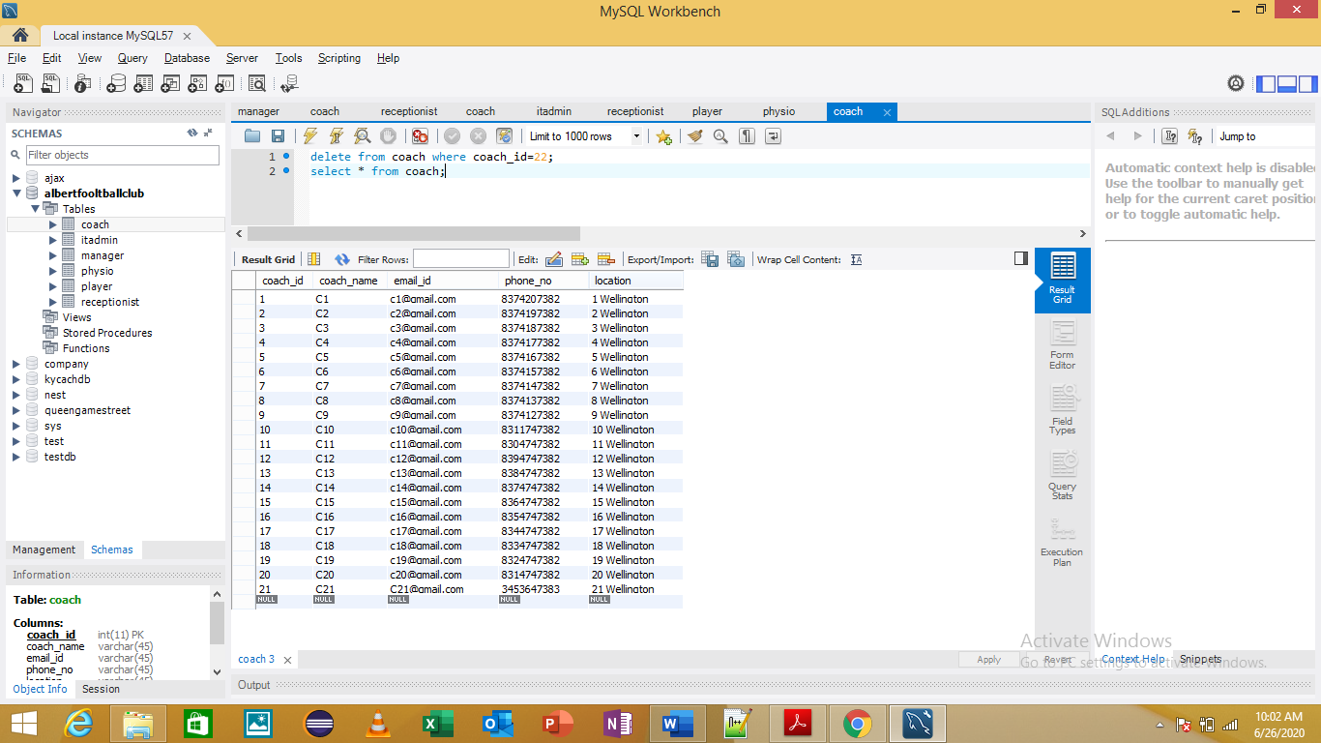

Primary Keys in Tables

Receptionist Table

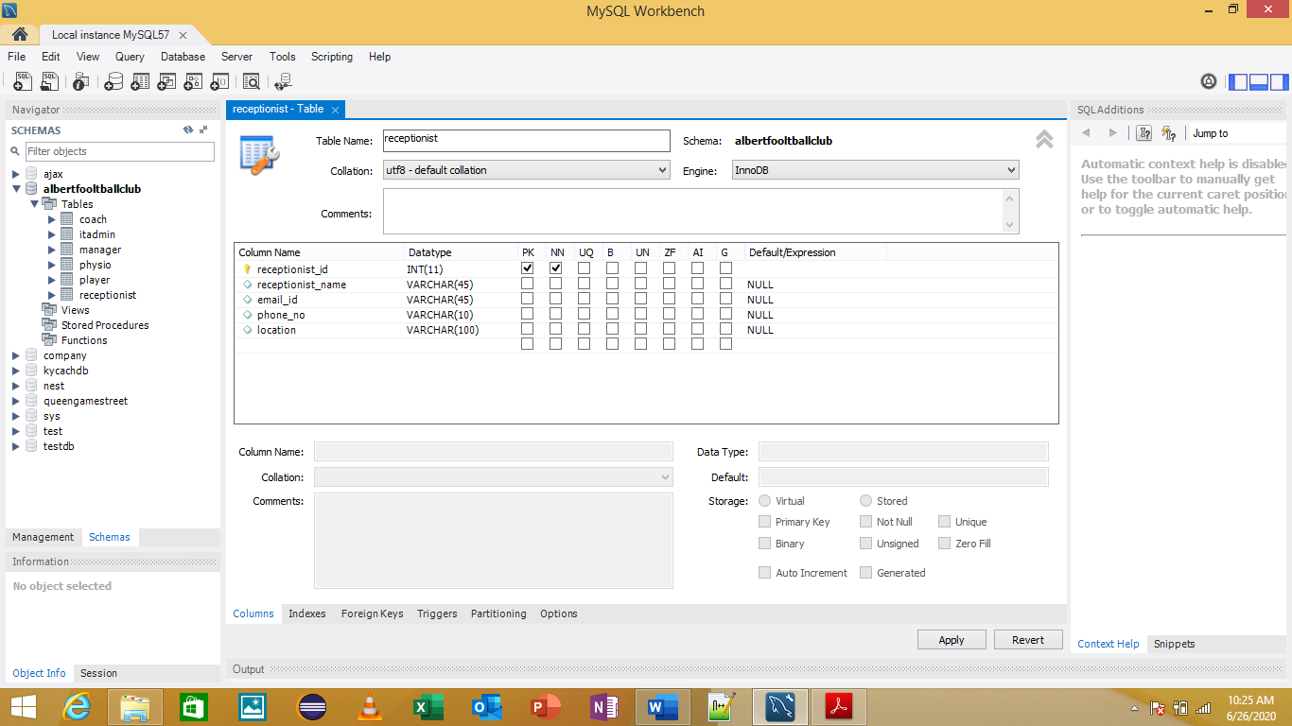

Player Table

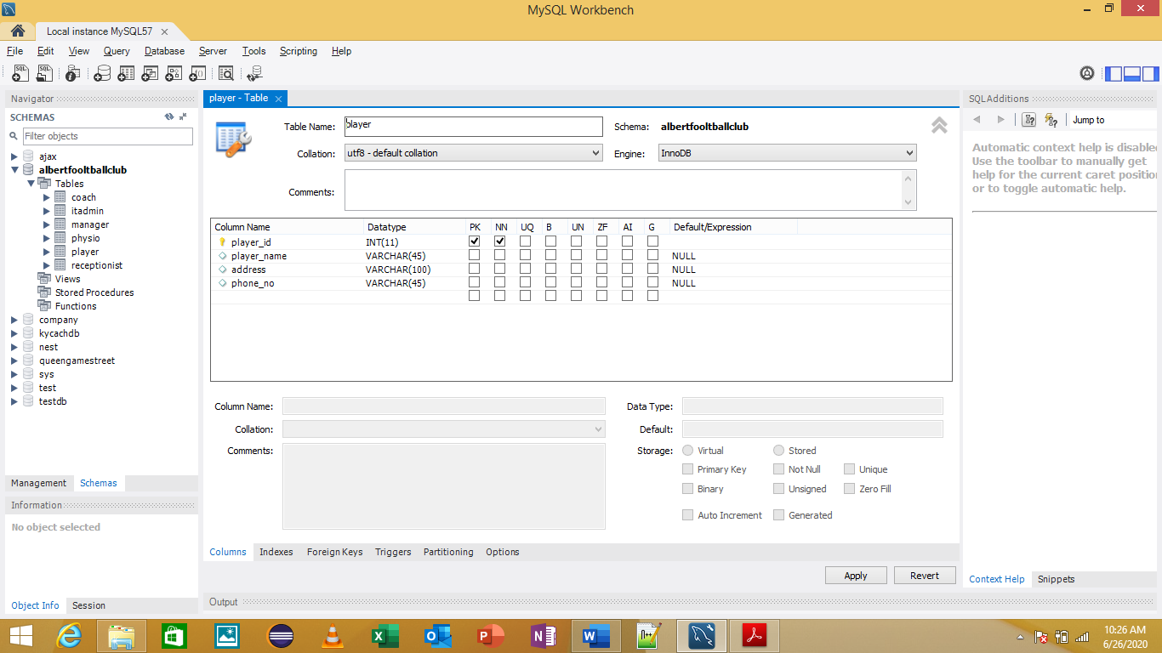

Manager Table

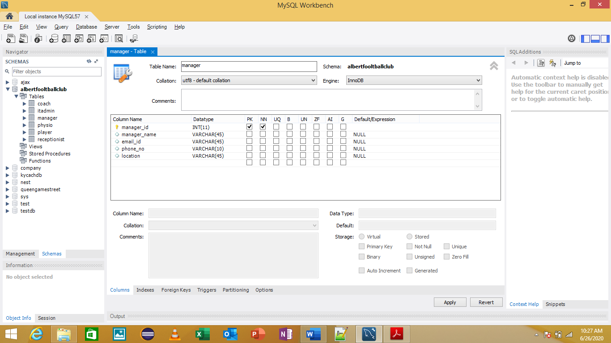

IT Admin Table

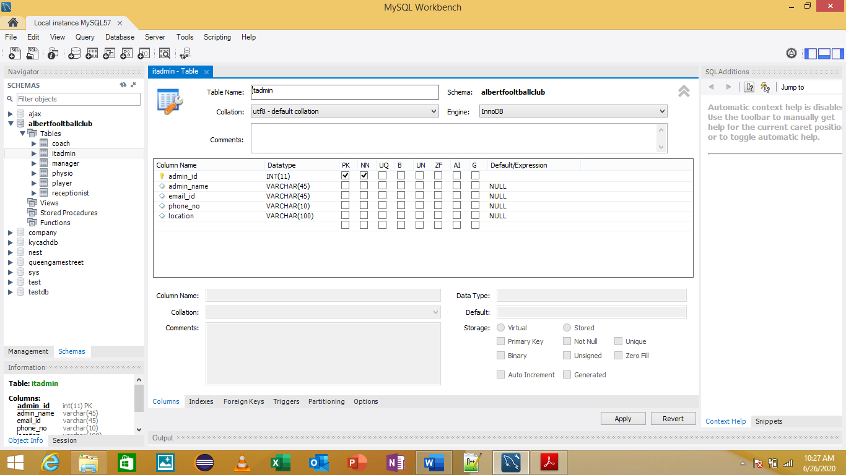

Coach Table

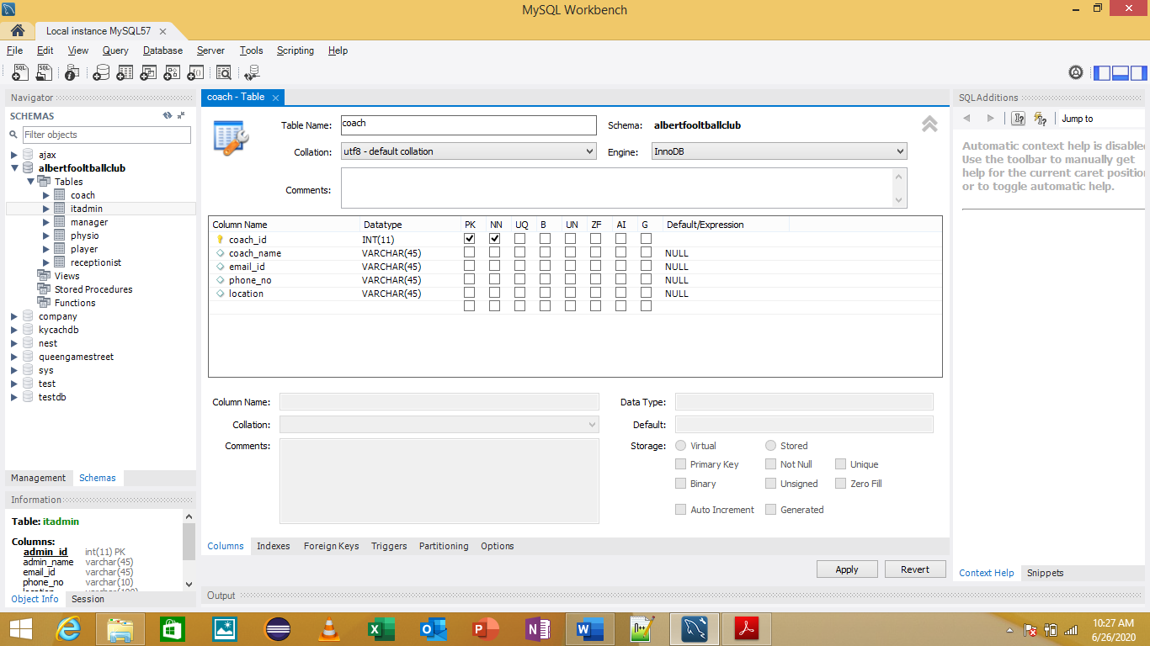

Physio Table

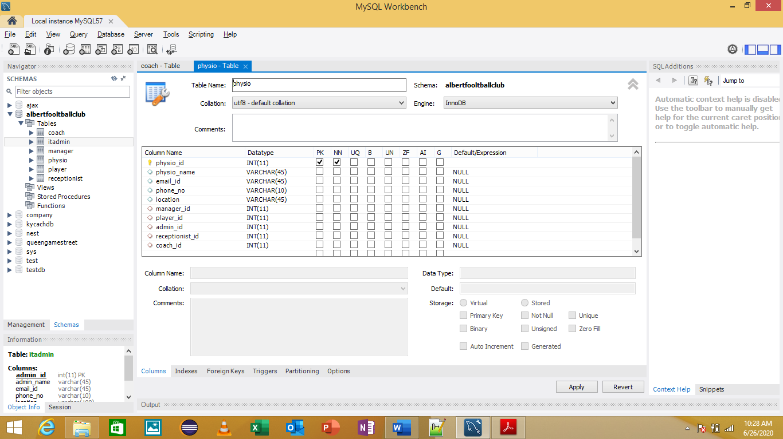

Testing Relationship Between Tables





EER Diagram



Data Export

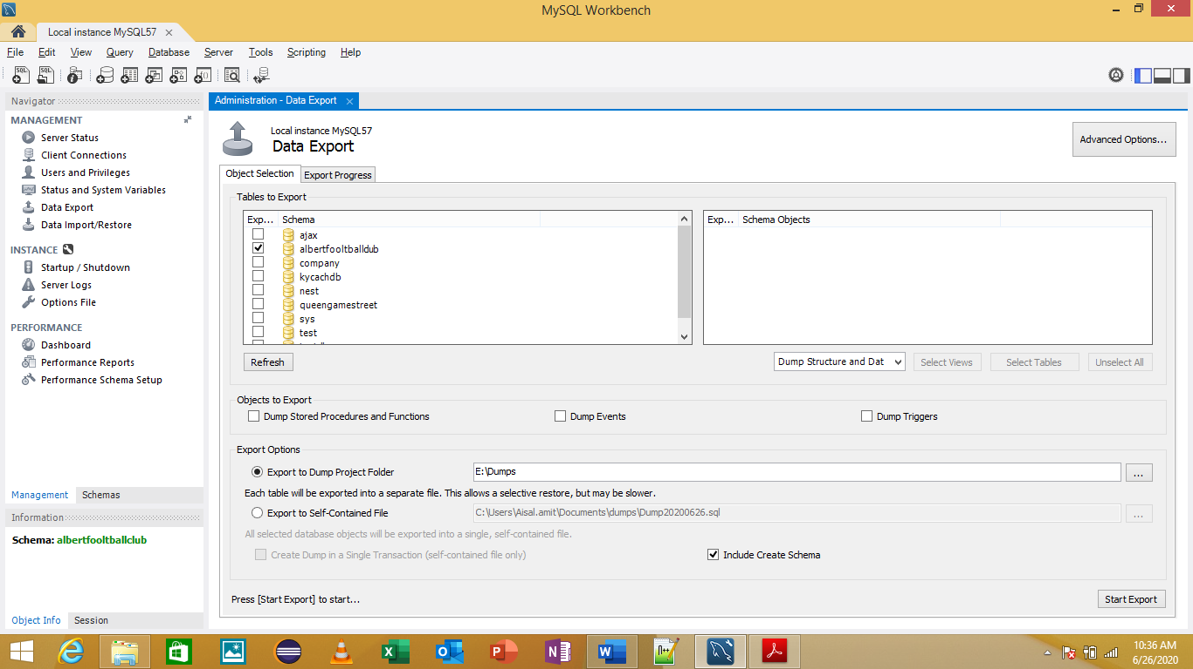

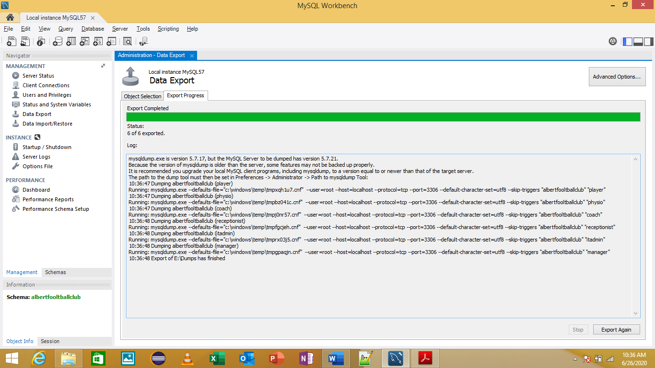

# References

* Technical Details – MySQL Workbench referenced from <https://dev.mysql.com/doc/workbench/en/>
* Technical Details – MySQL Introduction referenced from <https://www.tutorialspoint.com/mysql/mysql-introduction.htm>
* Back and Recovery referenced from <https://www.tutorialspoint.com/Database-Backup-and-Recovery> and <https://phoenixnap.com/kb/how-to-backup-restore-a-mysql-database>
* Export Data In MySQL referenced from <https://www.tutorialspoint.com/mysql/mysql-database-export.htm>
* Export Data in MySQL Workbench referenced from <https://dev.mysql.com/doc/workbench/en/wb-admin-export-import-management.html>